In Unit 2 (Graphics), Lab04 requires the use of a JAR file supplied by FCPS named karel2_c.jar which must be imported via:

**import** edu.fcps.Bucket;

The problem with the FCPS version of Bucket.java is that it does not expose an Accessor for the *water* variable, which represents the current water level of the bucket. The lack of an accessor for the bucket's current water level makes it ***difficult for students trying to solve Lab04 to programmatically display the water level of a given bucket instance*** periodically to see if the various calls to s*pill()* and pour() are having the desired effect.

To make the student's task a bit easier, I found source code for Bucket.java and modified it to include a new public accessor, getWaterLevel() that returns the current amount of water in a given bucket.

That will allow the students to do things like the following that are impossible using the FCPS-supplied version of Bucket.java:

// start with two empty buckets, one three gallon, the other five gallon

Bucket three = **new** Bucket(3);

Bucket five = **new** Bucket(5);

// 1. Fill the five-gallon bucket.

five.fill();

// 2. Pour from five into three until three is full.

// The remainder of the five-gallon bucket remains in that bucket.

five.pourInto(three);

*showWaterLevels*(three, five);

Where the method showWaterLevels is defined as:

**private** **static** **void** showWaterLevels(Bucket three, Bucket five)

{

System.***out***.println("Bucket three has " + three.getWaterLevel() + " gallons");

System.***out***.println("Bucket five has " + five.getWaterLevel() + " gallons");

}

Sample console output from the above appears below:

Bucket three has 3.0 gallons

Bucket five has 2.0 gallons

Bucket three has 0.0 gallons

Bucket five has 2.0 gallons

Bucket three has 2.0 gallons

Bucket five has 0.0 gallons

Bucket three has 2.0 gallons

Bucket five has 5.0 gallons

Bucket three has 3.0 gallons

Bucket five has 4.0 gallons

To keep the students focused on the code, rather than have them place Bucket.java inside their Lab04 folder, I encapsulated my modified version of Bucket.java in a separate JAR file named lcpsBucket.jar that can be referenced per Java's normal mechanism and then imported as needed.

The key to using my version of the JAR file is shown below, with the LCPS-edition of the required import commented out to help clarify the differences:

//import edu.fcps.Bucket;

**import** edu.lcps.Bucket.*; // includes getWaterLevel()

Since I don't have a LCPS GO login, I placed the JAR file into directory C:\projects\CompMath\unit02\jars\ as file lcpsBucket.jar and added it to the JGrasp CLASSPATH as shown below.

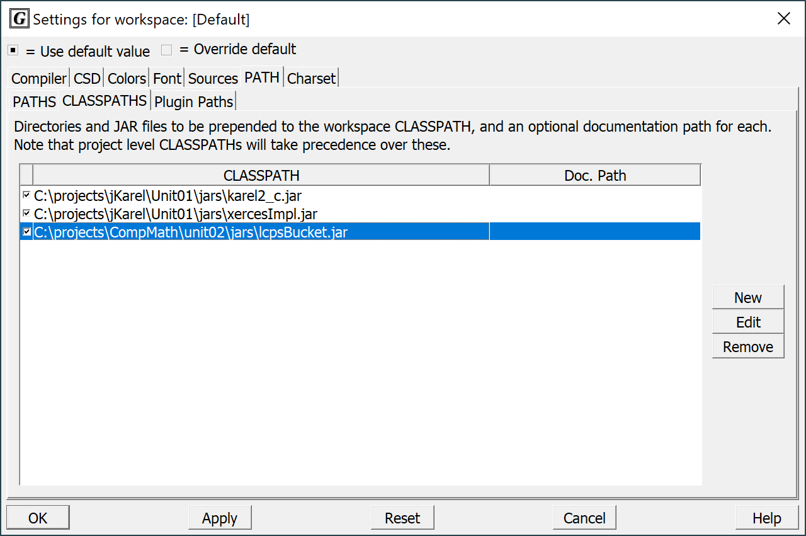

I hope this will come in handy and help lessen the student's stress level as they attempt to solve Lab04.